Middlesex Association for the Blind
Supporting people with sight loss since 1922

OUTLOOK
SPRING / SUMMER EDITION 2026
Barnet / Brent / Ealing / Enfield / Haringey
Harrow / Hillingdon / Hounslow / Richmond
This free MAB Outlook Magazine is produced in Print, Braille, USB and Email
Registered Charity No. 207007

About this edition: this is the accessible Word edition of OUTLOOK. The text reflows rather than sitting on fixed pages, every photograph has a text description, headings are real headings your screen reader can move by, and the contents entries below are links. The words are exactly as printed in the original magazine.

Contents
Mission Statement 4
Message from our CEO Valerie Hill 4
Donations, Wills and Legacies 5
Thank You for Your Donations 6
Testimonials: Home Visiting & IT Services 8
Postal Museum Audio-Described Tours 9
Volunteers Needed 10
Testimonials: Home Visiting Services 11
Testimonials: Employment & Counselling Services 13
Kew Gardens: Henry Moore Accessible Programme 16
MAB Services and News 16
NVision: Navigating the Internet 20
Testimonial: Let’s Chat Service User Volunteer 21
Other News – Intro to the Ray Ban Meta Glasses 23
HumanWare Brailliant / Richmond Talking News 26
British Library: Monthly Art Workshop 28
BrailleBliss Greeting Cards / VI Reformer Pilates 29
Buckingham Palace Garden Party 30
Seable’s Holidays for the Blind/Partially Sighted 31
British Wireless for the Blind Fund 31
RNIB Eye Care Support Pathway 32
Volunteer Recognition Scheme: Room to Reward 33
IT & Digital Training Services 34
Eye Matter – Information 35
A Clear Vision to Employment 36
MAB Board of Trustees 37
Disability Sports Coach / Hillingdon Tech Sessions 37
MAB VIP Social Clubs 38
Contact Numbers / Contributing to Outlook 42
Thank You 44

Mission Statement
The Middlesex Association for the Blind aims to support people who are blind or partially sighted to lead independent lives. The Association achieves this through the local provision and delivery of a range of high-quality services, advice and information to people across nine London Boroughs.

Message from our CEO Valerie Hill
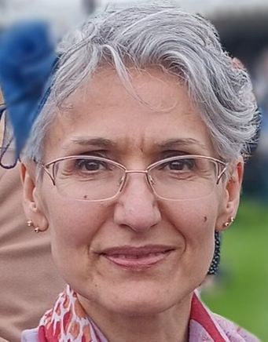
As the warmth of Spring and Summer returns, I am delighted to reflect on a truly memorable period for MAB.
I am proud that we now support over 900 residents across our nine boroughs. At the heart of our work, our anchor Home Visiting Service continues to thrive through the unwavering commitment of our staff and volunteers, while our mobile IT service champions digital inclusion through home visits and group sessions. Alongside these, our Counselling, Braille, Employment, and Social Club services each play a vital part in fostering independence and connection.
This Spring brought a moment we shall long treasure. At the beginning of May, we had the incredible honour of attending a garden party at Buckingham Palace, courtesy of our patrons, Their Royal Highnesses, The Duke and Duchess of Gloucester—a true highlight in the MAB calendar.
None of this would be possible without you. To our supporters, staff, and volunteers—thank you for making such a profound difference.
As we look ahead to brighter, warmer days, I do so with great optimism and pride in all that we will achieve together.
With heartfelt thanks and very best wishes.
Valerie

Donations, Wills and Legacies

We Know We Ask a Lot. Here’s Why — And Here’s Our Thank You.
First, to everyone who has already chosen to leave a gift to the Middlesex Association for the Blind in their Will — whether you told us, or whether it sits quietly in a document we may never see — thank you. You have looked beyond your own lifetime and said: I want the people who come after me to have the support I, or someone I love, once needed. That is a profound act of generosity, and we never take it lightly.
Now, with a smile and a degree of self-awareness, we want to write to those of you who may feel exhausted by our persistence.

We know we ask. Quite a lot.
If you’ve ever sighed at the sight of our number, we understand. And if our calls have ever felt like one too many, we’re sorry — that is never our intention.
But here is the truth behind the asking. MAB has no national parent charity, no endowment quietly earning income in the background. Every home visit, every IT training session, every phone call from someone newly diagnosed and frightened — all of it is funded entirely by grants, gifts and donations. Nothing else.
Right now we support over 900 blind and partially sighted people every single month. And legacy gifts, for a charity of our size, are among the most vital support we receive. They let us plan beyond next year’s budget. They let us say with confidence: we will still be here for the next person who needs us, and the one after that.
So when we call, we’re not calling to pester you. We’re calling because if we don’t ask, we don’t get — and if we don’t get, we can’t keep going. It really is that straightforward.

And we’re giving something back.
We’ve partnered with Octopus Legacy, one of the UK’s leading will-writing services, so every supporter can write or update their will completely free. Not discounted — free, with no strings attached and no obligation whatsoever to include MAB. Simply quote the code MABfree. You can do it online, by phone, or face to face — whatever suits you.

No pressure. Ever.
Your will is yours. Provide for the people you love first. Then, if you choose, consider the causes that have mattered in your life. If we’re among them, we’d be honoured — not because we asked, but because you decided.
And to those who’ve already made their gift: we said it at the start, and we’ll say it again. Thank you — from every one of the 900 people we support each month.
To write your will for free, contact Octopus Legacy quoting MABfree.
Telephone 020 4525 3605 | www.octopuslegacy.com
Middlesex Association for the Blind | Charity Registration No. 207007.

Thank You for Your Donations
DONATIONS WELCOME
Thank You!
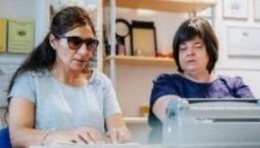
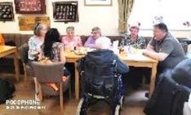
Thank you for supporting us. With your Financial Gift, we can help people who need us. Losing sight can be terrifying and anxiety provoking. With your help, we can enable people who have a Visual Impairment to maintain their Independence and regain their Mental Wellbeing.
Call 020 8423 5141 to Donate by Phone.
Go to www.aftb.org.uk to Donate Online.
Or Scan the QR Code below.
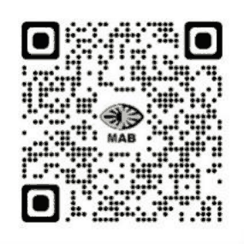

Testimonials: Home Visiting & IT Services

Home Visiting Services ~ Chanel Mahay ~ Camilla Konieczny ~ Joanne White ~ IT & Digital Services:- Marc Davis ~ Tomasz Szuberski
You have two very good workers in Marc and Chanel, and I know there are many other MAB Service Users who would say the same thing. Both of them have been extremely helpful to me. Chanel is lovely to get on with and she is excellent at her job. She helps me a lot in doing things like finding things on the internet that I cannot find. She has done many things for me that have saved me money and she is full of sympathy which is great because we all need that sometimes. Even though I am always encouraging people to look on the positive side of life, even with sight loss, there are some days when I also need some encouragement, and Chanel is always able to do this for me. I can find no fault with her. Life has been hard since my partner got an incurable disease and went to a care home. My brother has also died, so I have no family left. Chanel’s coffee mornings are really important as it gives us a chance to get together and to help each other. Marc is getting me more tech savvy, which is very helpful, and he has also helped me with writing some communications that needed to be sent. My challenge is that I struggle with trust, as I have had bank fraud and other instances of financial abuse. Having people like Chanel and Marc whom I can trust, as well as the other people in your organisation, this makes a big difference to me.
Service User Testimonial: David – L. B. of Ealing
Josephine was referred to us from the Hounslow Council Adult Social Services. She has this to say about our IT training, “Marc, the IT trainer, has been a great help. I have only recently become blind and I wasn’t aware of all the technology that is available to help someone like me. He told me about the Ray Ban glasses – he brought them to me and showed me what they can do. I need to get a phone now so that he can put all the Seeing AI on to it. I don’t have a phone or a laptop, as I am living in a hotel after having been evicted from my home, so I now have to save up to be able to rebuy all of these things. Marc has been really helpful telling me the kind of phone that I need. I am hoping to buy it next week and he will be coming soon to help me to use it”.
Service User Testimonial: pseudonym Josephine – L. B. of Hounslow
The IT training is very helpful to me as I am losing my sight. I have a tiny bit left, but the internet keeps persistently changing, which is very hard for me, as I end up lost, not knowing what to do. Marc has helped me with a lot of problems – my printer went mad recently, and he was able to fix it for me. Without Marc I would be stuck, as my son is my carer, and he would normally do all these things for me. But his health isn’t good right now, so he isn’t able to get to me to help me. I also have a MAB volunteer, Belle, who is also fantastic. She comes to me every 3 weeks and we have a good chat. She does some shopping for me, and most importantly for me – she also does some sewing for me, which is brilliant!
Service User Testimonial: Susan – L. B. of Hillingdon

Postal Museum Audio-Described Tours
Audio-Described Tour of the Postal Museum, for the Visually Impaired.

Includes entry to all exhibitions, the audio-described tour and an optional ride on Mail Rail. Cost £3.50 per person. Visitors are also welcome to book a free space for one accompanying companion. Tour is led jointly by Audio Describer from VocalEyes & a Museum Curator.
Saturday 3rd October – 10AM. Friday 27th November 2026 – PM Tour
https://www.postalmuseum.org/event/audio-described-tours/

Volunteers Needed

You can Make a Real Difference!
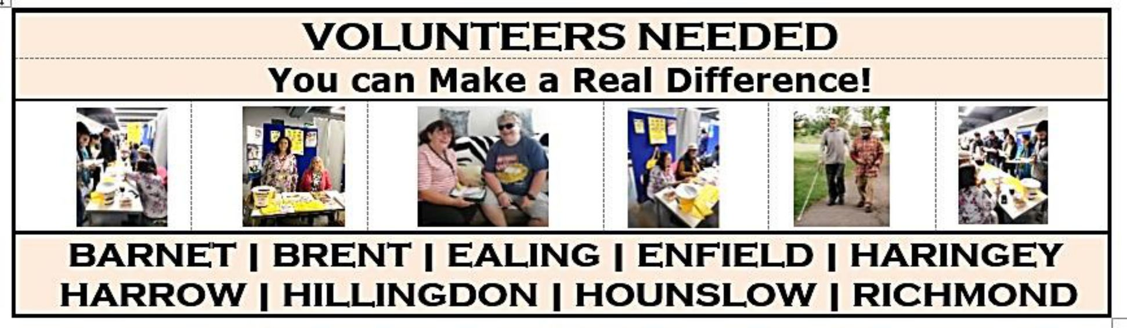
- BARNET
- BRENT
- EALING
- ENFIELD
- HARINGEY
- HARROW
- HILLINGDON
- HOUNSLOW
- RICHMOND

Testimonials: Home Visiting Services

Home Visiting Services ~ Bina Padia ~ Alison Bicknell
I have had one session with Tomasz so far, and I tell you he is a wizard! He is so amazing and so kind. I wanted the IT training sessions so that I could phone my family and my friends. Without my sight, I was unable to do this. I also thought that I needed to buy a new phone to be able to use the right technology. But Tomasz looked at my phone at the VIP club and he said that wasn’t necessary at all. He said I could use my existing phone. This was such a relief to me as it has saved me money. In the first session Tomasz taught me how to use Siri. So now I can say, ‘Siri, phone so and so,’, or ‘Siri, please read my messages to me!’ These are things that I didn’t know how to do before, and now I can do them. I am so happy. I couldn’t ask for anyone better to be helping me with this.
Service User Testimonial: Esperanza – L. B. of Barnet
Tomasz, the IT trainer, has taught me so much. Without him I would have no digital freedom and I can say that with absolute certainty. I was using my phone in a very basic way before, and now I know so much more. Tomasz is worth his weight in gold. I can now text, use Whatsapp, use voice over, Gemini and a whole lot more. He is coming to see me again this afternoon. Prior to losing my sight I was boxer, I was semi-professional. I was active on YouTube, and I was also rock climber. When I lost my sight, I lost all my self-worth. I feel like a bird who has had its wings clipped. Most mornings I wake up and think, “Oh God, why am I still alive?” I have become introverted; I don’t mix with anyone anymore and I just want to be left alone. But having Tomasz has given me one person to engage with and the opportunity to advance myself in one way. Without Tomasz I would be a recluse, I would be socially awkward and very upset. Don’t get me wrong, I still cry every day, but I don’t cry for the whole day anymore. Tomasz has made this more palatable. Every second I have with Tomasz is invaluable to me.
Service User Testimonial: pseudonym Sean – L. B. of Harrow

Home Visiting Services ~ Joanne White ~ Camilla Konieczny
Without MAB my life would be very difficult. Joanne is the Support Worker in Hillingdon who visits me regularly and helps me with reading my mail. She makes sure I don’t miss anything important. She is bringing a volunteer to me next week too, and that person will take over from there helping me. I have been with MAB for years now and the organisation has helped me extensively. A while back I was having problems as I live in sheltered accommodation with my guide dog. People were complaining that my dog was messing, and it actually wasn’t my dog. I was reported to some authority, and eventually Guide Dogs were able to advocate for me and stop the discrimination. But it was MAB who supported me throughout that process. I am very grateful to them!
Service User Testimonial: Scot – L. B. of Hillingdon
Camilla, the new Support Worker in Hounslow, is lovely. It is clear that she wants to help. She comes once every three weeks to help me to carry my shopping. Everybody says, “Oh, but you could just have that delivered”, but the fact is that you have to spend above a certain amount before you can get a delivery for free, that is impossible for my budget. I simply cannot afford it. So Camilla comes every three weeks and takes me and my heavy shopping home. We are so good at it now, we do it incredibly quickly. Then in addition to Camilla, I have volunteer who comes to me every other Friday. She helps me with a whole host of things. Right now she is helping me to get my club card working again, as it has stopped for some reason. Without MAB, my life would be very hard.
Service User Testimonial: Myrtle – L. B. of Hounslow
Camilla is a really nice person. If it weren’t for her and her visits to us, then my husband and I wouldn’t be able to read our mail, which is paramount. We find the service very helpful. My husband used to be able to read the mail for both of us with a magnifier, but his sight has also deteriorated and it is not possible for him to do that anymore. I have been a member of MAB for years – I think since 2014, but I have only had to start making use of this service recently. It is an invaluable service.
Service User Testimonial: pseudonym Susanna – L. B. of Hounslow

Home Visiting Services ~ Caroline Adamson ~ Ruth Gaskin
I have received so much encouragement from your organisation. I thought I was the only one going through what I am experiencing. But after Caroline came and saw me and linked me up with other people in the VIP club, I am feeling so much better. She has linked me with a community of people who are also experiencing sight loss, and it has been extremely helpful and I am benefiting a great deal. It has changed the quality of my life.
Service User Testimonial: Sarah – L. B. of Haringey
The VIP club is very good. It is just starting, and Ruth, Support Worker is very helpful in helping people overcome their challenges like transport to and from the club. In the meeting that we had Patrick and I were able to exchange information about AI and software on the phone. It was very good for me to be there and I will be happy if it continues and grows.
Service User Testimonial: Shahram – L. B. of Enfield

Testimonials: Employment & Counselling Services

Employment Services – John Monkhouse & Marc Hill
Employment Service Team Visual Impairment Awareness Training in Richmond was well received. See comments below.
“I also wanted to say a massive thank you to John, Kiranjeet and Mark! They left not long ago after a brilliant training session which our team absolutely loved. It was interactive, engaging, immersive and very informative. Thank you so much for offering to run this session and for coming to Richmond to facilitate this.”
Grant Officer Testimonial: Cally – L. B. of Richmond

Rapid Response Counselling Service – Raheel Razvi
MAB CEO Valerie Hill sharing some lovely feedback on our Rapid Response Counselling Service, from a Brent Service User.
Dawnette called to let me know how "absolutely amazing" our counsellor Raheel has been. She commended his service delivery, commitment and dedication and told me that his support helped her through a great deal. She had been receiving counselling from Raheel over several years, gradually reducing the frequency of her sessions as she grew stronger, until she realised she is now in a much better place and no longer needs that support. She is working and is about to get married in August and although there are still obstacles linked to her sight loss, she feels far better equipped to deal with them and to live her life to the full. She was more than happy for me to share her words with the team. Raheel, she could not praise you highly enough. You should be very proud of the positive impact of your work. Thank you.
Service User Testimonial: Dawnette – L. B. of Brent
Raheel is making a big, massive, difference in my life, to be honest. I am supposed to have had heart surgery, but it hasn’t happened yet. As a result of my condition, I have lost mobility in my legs and I have become 100% blind in my one eye. The disc in my other eye is distorted. So I am now severely visually impaired. As a result of this I became depressive, and experienced a lot of rage. MAB has helped me to manage this. I am supposed to have therapy sessions from Brompton Hospital, but these are now online, and online doesn’t help me at all. Having Raheel come to my house, to have a cup of tea with me and to talk through the problems I have and what I want for the future – this is like having a friend, a counsellor, a psychologist and most importantly, a person – all rolled into one. You have a beautiful organisation doing such amazing work!
Service User Testimonial: Paulo – L. B. of Ealing

Barnet Home Visiting Services – Bina Padia
I've recently started receiving support from MAB. My support worker, Bina has been extremely helpful and has always been available for a chat and reassurance. She has put me in touch with a volunteer who has taken me out for a walk. As I'm unable to walk without assistance this has been invaluable for me and has had a very positive psychological effect on me as I feel no longer trapped in my house. I cannot praise MAB highly enough. They have given me lots of advice and have been a great support for me. They've also put me in contact with another visually impaired person on my street which again has made me feel less isolated and given me someone to talk to. And our Thursday VIP club is so much fun! My life has changed so much for better thanks to this amazing organisation and their kind and caring people! Thank you from the bottom of my heart!
Service User Testimonial: Natalia – L. B. of Barnet
Volunteer: Périne

Kew Gardens: Henry Moore Accessible Programme




https://www.kew.org/kew-gardens/henry-moore-accessible-programme
KEW GARDENS, KEW, RICHMOND LONDON TW9 3AE
TEL: 0202 8332 5655 ~ INFO@KEW.ORG

MAB Services and News
We are pleased to introduce the MAB Team:
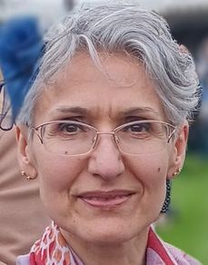
Valerie Hill — Chief Executive Officer
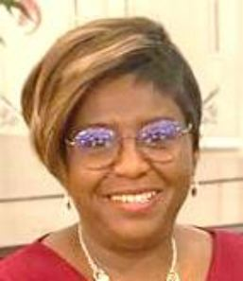
Patricia Odina — Operations Manager
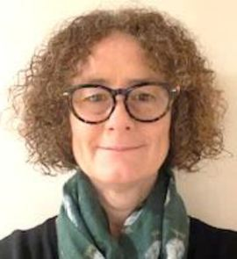
Catherine Holtzhausen — Fundraising Manager
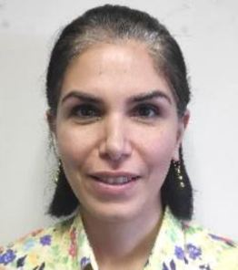
Shahin Toopchian — Bookkeeper / Admin Assistant
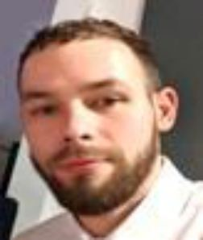
Tomasz Szuberski — Mobile IT Support Trainer 5 Boroughs

Marc Davis — Mobile IT Support Trainer 4 Boroughs
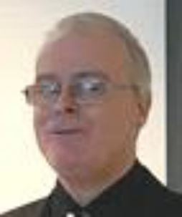
John Monkhouse — Employment Services Officer
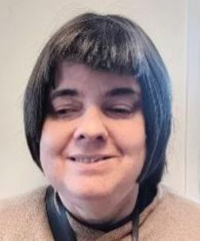
Maggie Dawson — Braille Tutor

Nasreen Akhtar — Office Administrator
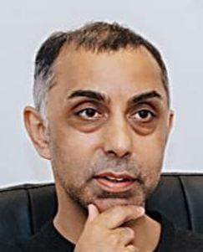
Raheel Razvi — Rapid Response Counsellor
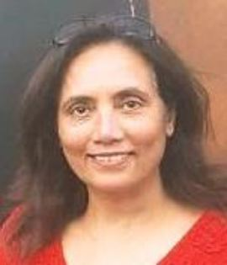
Bina Padia — Barnet Support Worker & Coordinator
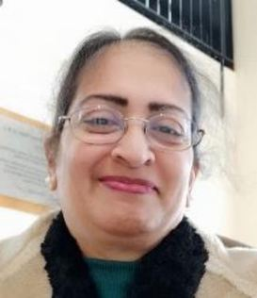
Rita Shah — Brent Support Worker & Coordinator

Chanel Mahay — Ealing Support Worker & Coordinator
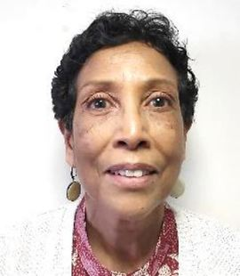
Gloria Powell — Enfield Support Worker & Coordinator
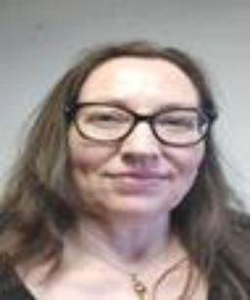
Caroline Adamson — Haringey Support Worker & Coordinator
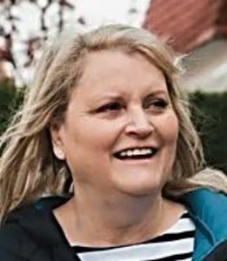
Alison Bicknell — Harrow Support Worker & Coordinator
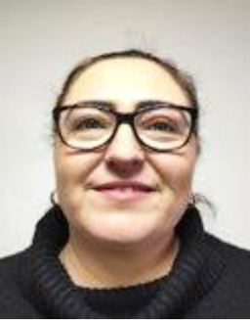
Joanne White — Hillingdon Support Worker & Coordinator
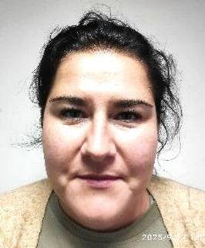
Camilla Konieczny — Hounslow Support Worker & Coordinator
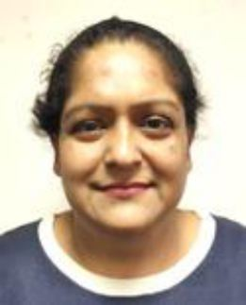
Harvinder Sachdeva — Richmond Support Worker & Coordinator

Kiranjeet Khurana — Fundraising Intern
Hasmukh Mehta — Head Office Volunteer
Marc Hill — Employment Service Volunteer
Thank you all for your valuable contribution. We are very grateful for the hard work and dedication of all team members, past & present. Thank you for always striving to make a positive difference to the lives of people with a visual impairment.

NVision: Navigating the Internet

This is a free online resource dedicated to helping people live better by seeing better. They recently published an educational guide to navigating the internet for individuals with low vision or blindness. Our free resource covers the built-in tools that make sites more accessible for people with vision loss. Please take a look: nvisioncenters.com/internet-accessibility-guide/

Testimonial: Let’s Chat Service User Volunteer

Let’s Chat Service User Volunteer Project
Audrey is matched with Carla, one of our Let’s Chat Phone Buddy Volunteers, and they speak every Monday. “I have been isolated as a result of my visual impairment so I really appreciate the calls with Carla. We have a lot in common as we are both visually impaired, and speaking to her has helped me so much. She never interrupts me or tells me what to do, she allows me to talk, and then she also gives me tips about practical things like putting a notch on the different pairs of glasses that I have, to work out which are the indoor ones and which are the outdoor ones. She also told me about a temperature probe that I can use to find out how hot my food is. She understands the frustrations I experience with things like the carers moving things in my house. I can spend a whole morning looking for something that is right in front of me. Carla also understands things like how long it takes to get out of the house. When I had my sight, I could get up, shower and be out the door in 40 minutes, now, I have to start preparing the night before to have everything in place for me to be able to leave the house in the morning. I have four grandchildren but I have been reluctant to get them involved in my care as I didn’t want to be a burden. But Carla has a son, and when I listened to her speaking about how he helps her, I had the courage to reach out to my grandchildren. It is lovely to have them around! They now think all the time about what Nanny needs and because they are so good with technology they can do things like order things on Amazon for me. We have also started exercising together, as I used to run before I lost my sight. I am picking it up again now and I want my grandchildren to run a 5km run with me. I think that they now have a radar for other vulnerable people. One of them told me that he had offered his seat on the bus to someone who had a walking stick – I don’t know that he would have done that before. Because of Carla I have also expanded my community and gone back to church again. This is helping to reduce my social isolation. I am a trained lawyer, but since speaking to Carla I have gone back into further education and trained to be a disability advocate. I hope that I can raise money for the Middlesex Association for the Blind one day through getting in sponsorship for a marathon.
Service User Testimonial: Audrey – L. B. of Barnet

Other News – Intro to the Ray Ban Meta Glasses
IT & DIGITAL FEATURE - BY TOMASZ SZUBERSKI

An introduction to the new Ray-Ban Smart Meta Glasses (Generation 2)
I want to highlight the importance of technology and how it can significantly improve the lives of people who are visually impaired. Recently, we acquired the new Ray-Ban Smart Meta Glasses (Generation 2), which, in my opinion, is a real game changer when used correctly. Most of the people I visit are not even aware that this technology exists. When I demonstrate the glasses and show what they can do, people are often genuinely amazed. I must also mention that specialist visual impairment technology is extremely expensive, and many individuals simply cannot afford it. This is where the Ray-Ban Smart Glasses stand out - they offer powerful assistive features at a fraction of the cost of traditional high-end VI technology, while providing even broader functionality. With the integration of AI, the glasses can take photos and videos, check the weather and time, set reminders, play music, make and receive calls, send and receive messages, (including WhatsApp), identify objects, distinguish between products, read and summarise text, translate text instantly, and describe what is in front of the user, and much more. Furthermore, with its integration with the Be My Eyes App, there is currently no other device that offers such a comprehensive level of assistance for visually impaired individuals, in everyday life. Key features:
Meta AI – Chat with Meta AI for on-the-go suggestions and answers. You can ask the glasses to help brainstorm ideas, suggest recipes, set reminders, and more.
Battery Life – Up to 8 hours of battery life, allowing more time for use and less time charging.
Enhanced Capture – Capture what you see and hear without taking out your phone. Features an ultrawide 12MP camera and a five-microphone system, supporting high-quality 3K video recording.
Listen – Built-in open-ear speakers deliver sound only you can hear, while five microphones provide clear audio for phone calls. Great for listening to music while still being aware of surroundings.
Controls – Hands-free voice commands allow you to call, message, take photos/videos, and manage media settings while your phone stays in your pocket.
Meta AI App – Required to set up and manage the glasses, access new features, and keep the device updated.
Lens Options Available In: Graphite, Clear/Grey Transitions, Clear, Clear/Graphite Green Transitions, G-15 Green, and Clear/Sapphire Transitions.
Conversation Focus: Uses AI to isolate and amplify the voice of the person in front of you in a noisy environment.
Spotify Integration: Enables "Meta AI" to play a song that matches what's in your view.
New Voice Commands: Support for French, German, Italian, Portuguese and Spanish for music control.
Expanded AI Capabilities: "Detailed Responses" provide richer, descriptive narrations of surroundings for improved accessibility.
4th Gen Hardware Rumors: Future, rumored, 4th Gen glasses possibility include in-lens display for enhanced augmented reality (AR) functionality, Improved camera, better battery, possibly launching later in 2026
Cost – £379.00 - £459.00
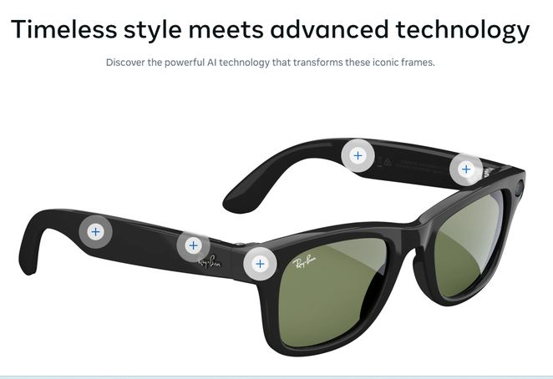
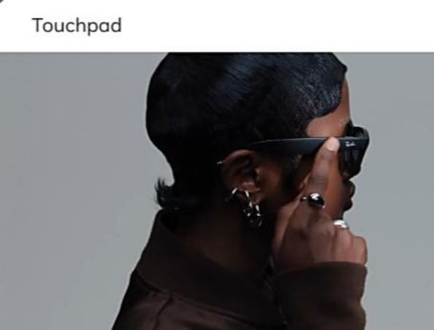
Control the full experience with a touch. Tap to play or pause, swipe for volume or tap and hold to launch your favourite music App.
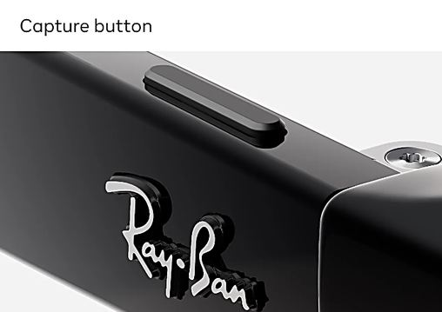
Capture what you see and hear quickly with a button built into the right temple of your glasses.

Say “Hey Meta, take a video” and an ultra-wide 12 MP camera records what you see in even higher quality than before, with new 3K Ultra HD

Discreet, open-ear Bluetooth speakers deliver high quality audio without blocking out conversations or ambient noises around you.

Ray-Ban Meta (Gen 2) provides up to 8 hours of battery life, plus 48hours more with a fully charged case. [Gen 1 offers up to 4 hours of battery and 36 hours with a fully charged case].

HumanWare Brailliant / Richmond Talking News

The new Brailliant BI 40X & Brailliant BI 20X


Think SMART, Think BRAILLIANT!
HumanWare specialises in the design and manufacture of highly intuitive and intelligent solutions for people living with vision loss or visual impairment.
From electronic magnifiers to talking GPS to braille devices, HumanWare solutions help all users live independently and participate successfully in today’s world.

Richmond Talking News

Do you have difficulty reading the newspaper?
Do you enjoy hearing about local news?
If so, listen to it!
Richmond Talking News will send it every week to your doormat, Alexa or mobile – and it’s free.
Contact us and we’ll set you up to receive Richmond Talking News:
t: 020 8892 0826
e: hello@rtn.org.uk
w: rtn.org.uk
Registered charity no.277713

British Library: Monthly Art Workshop
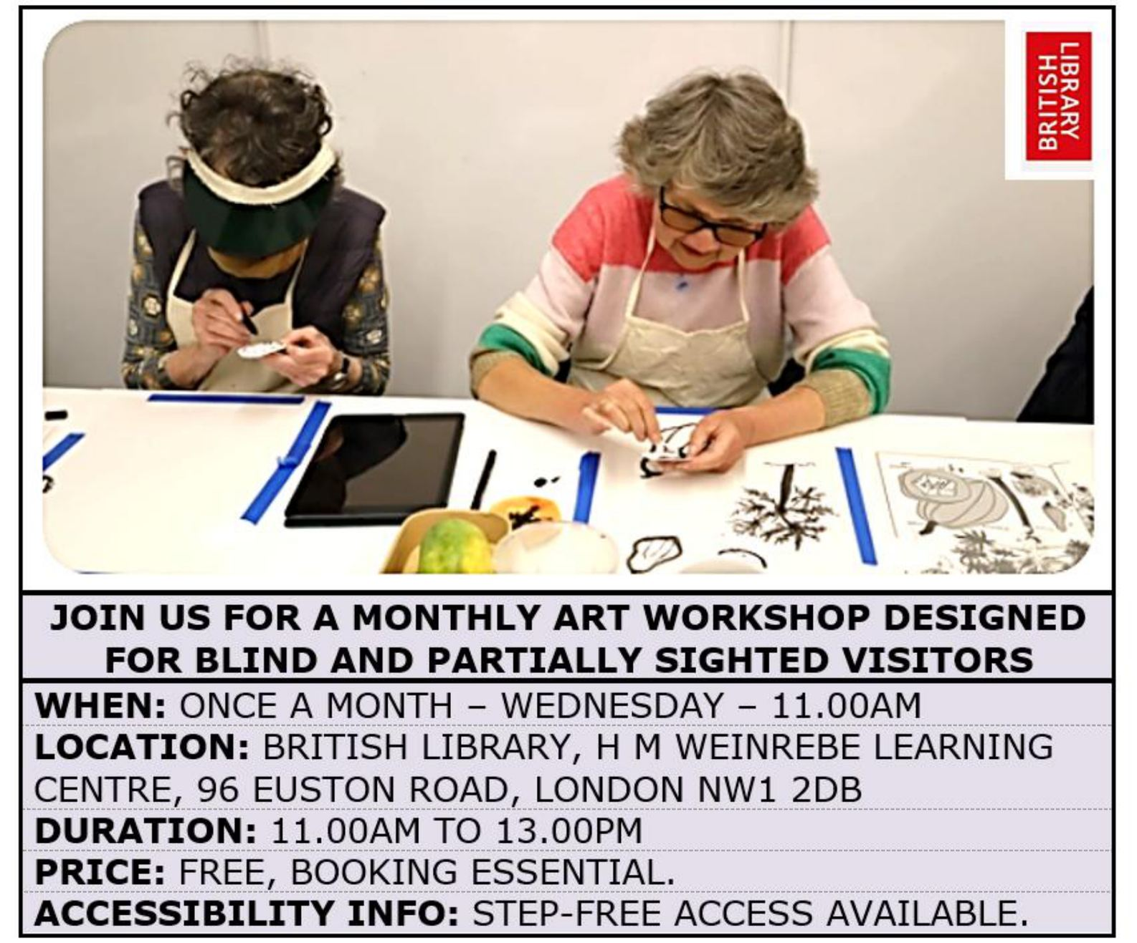
JOIN US FOR A MONTHLY ART WORKSHOP DESIGNED FOR BLIND AND PARTIALLY SIGHTED VISITORS
WHEN:
ONCE A MONTH – WEDNESDAY – 11.00AM
LOCATION:
BRITISH LIBRARY, H M WEINREBE LEARNING CENTRE, 96 EUSTON ROAD, LONDON NW1 2DB
DURATION:
11.00AM TO 13.00PM
PRICE:
FREE, BOOKING ESSENTIAL.
ACCESSIBILITY INFO:
STEP-FREE ACCESS AVAILABLE.

BrailleBliss Greeting Cards / VI Reformer Pilates

BrailleBliss

Braille Greeting Cards
The link to Kerry’s Online Shop is below: BrailleBliss.etsy.com
Donations to be made from Sales to Guide Dog UK

Visually Impaired Reformer Pilates

WHO?
ADULTS WITH VISUAL IMPAIRMENT – NO PREVIOUS EXPERIENCE REQD
WHEN?
TOTTENHAM STUDIO, NORTH LONDON
WHERE?
ONE SATURDAY PER MONTH AT 2.30PM & 3.30PM
FIND OUT MORE
INFO@FIRSTREFORM.STUDIO. WHATSAPP – 07940 369394
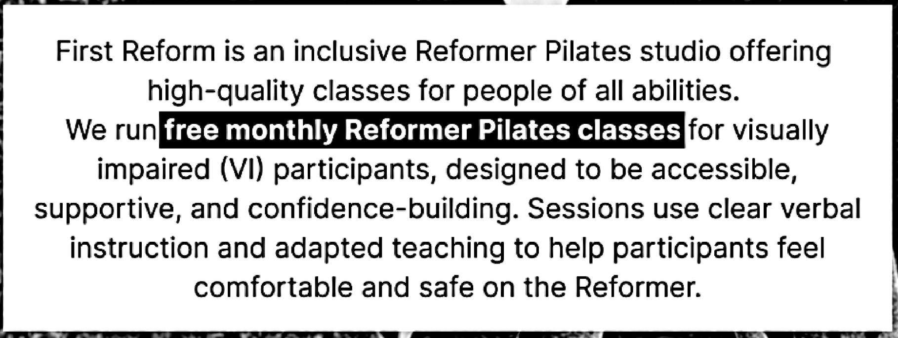
First Reform is an inclusive Reformer Pilates studio offering high-quality classes for people of all abilities. We run free monthly Reformer Pilates classes for visually impaired (VI) participants, designed to be accessible, supportive, and confidence-building. Sessions use clear verbal instruction and adapted teaching to help participants feel comfortable and safe on the Reformer.

Buckingham Palace Garden Party
MAB received an invitation from TRH the Duke and Duchess of Gloucester for four guests to attend a Garden Party hosted by His Majesty The King at Buckingham Palace on the afternoon of Wednesday 6th May 2026. Raj Mehta, our Chair of Trustees, Qas Khattak, our Trustee, Valerie Hill, our CEO and Joanne White our Hillingdon Support Worker were selected to represent MAB.
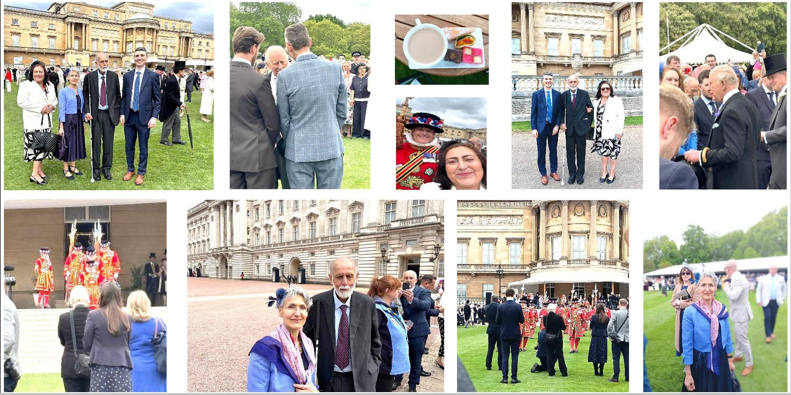

Seable’s Holidays for the Blind/Partially Sighted
Holidays for the Blind & Partially Sighted
Seable’s mission is to provide accessible tailored holidays to the visually impaired community. Amazing, inclusive trips with local sighted guides and tailored activities to suit your needs and enjoy a stress-free holiday. Telephone: 020 3375 6947. www.seable.co.uk

British Wireless for the Blind Fund
Explore the Range of Radios, Alexa Devices & Other Equipment given Free of Charge to the Visually Impaired
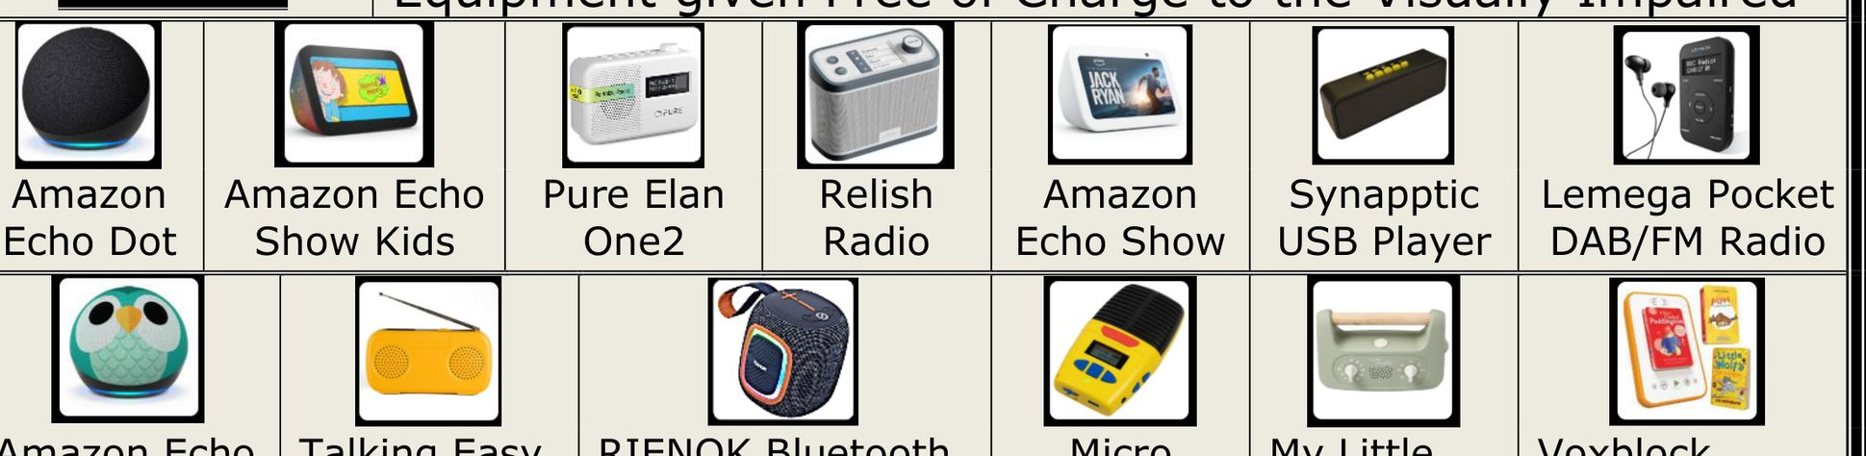
- Amazon Echo Dot
- Amazon Echo Show Kids
- Pure Elan One2
- Relish Radio
- Amazon Echo Show
- Synapptic USB Player
- Lemega Pocket DAB/FM Radio
- Amazon Echo Dot Kids
- Talking Easy Music Player
- RIENOK Bluetooth Speaker
- Micro Speak Plus
- My Little Morphee
- Voxblock Starter Pack

RNIB Eye Care Support Pathway
RNIB EYE CARE LIAISON OFFICERS - ECLOs
For more Information, or For a Referral to the ECLO in your Area, Please Call the Helpline at 0303 123 9999
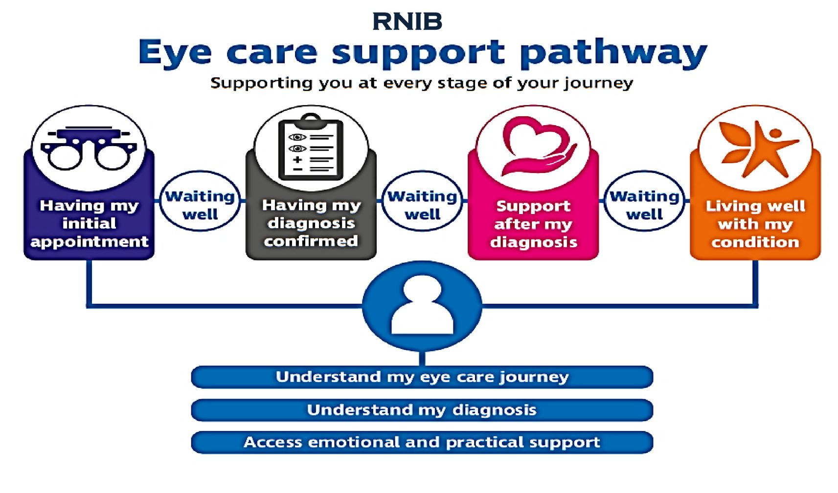
RNIB Eye care support pathway — Supporting you at every stage of your journey:
Having my initial appointment – Waiting well – Having my diagnosis confirmed – Waiting well – Support after my diagnosis – Waiting well – Living well with my condition
- Understand my eye care journey
- Understand my diagnosis
- Access emotional and practical support

Volunteer Recognition Scheme: Room to Reward
Hotel Breaks for Hidden Heroes - Room to Reward is a unique Volunteer Recognition Charity created to Say ‘Thank You’ to inspirational Volunteers who give up their time to make a difference to others. Their Hotel & Holiday Park Partners, donate their unsold rooms. Charities like MAB nominate their Hidden Heroes for a break – Room to Reward make it happen!
In 2026, MAB with the help of our Support Workers nominated the following five MAB Volunteers as Hidden Heroes and recipients of a Room to Reward Hotel Break:
- London Borough of Barnet – Arun Kalraiya.
- London Borough of Brent – Jeff Oliver.
- London Borough of Harrow – Tarla Modha.
- London Borough of Hillingdon – Alexander Guberman.
- London Borough of Richmond – Carole Batcup.
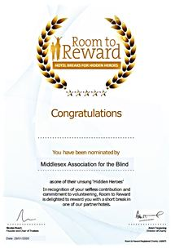
We are delighted to announce that all five nominations were successful recipients of a Hotel Break of their choosing. Each Volunteer also received a Hidden Hero Certificate.
CONGRATULATIONS & THANK YOU!

IT & Digital Training Services
TRAINING ~ ADVICE ~ SUPPORT ~ DEMONSTRATIONS
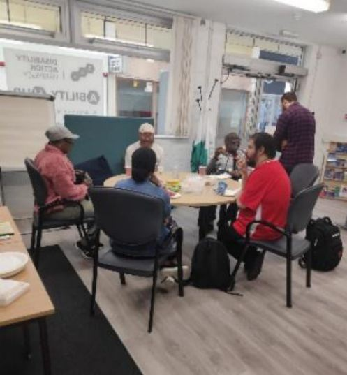

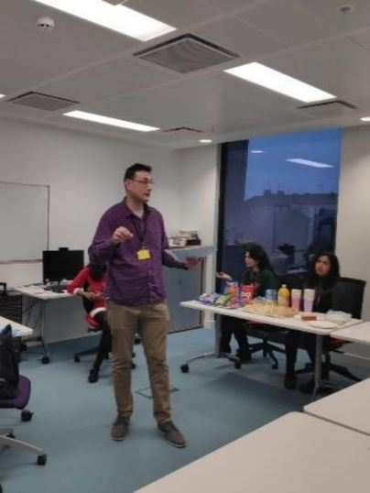
Visit our website www.aftb.org.uk or Call 020 8423 5141

Eye Matter – Information
Eye Matter - Multi-Activity Peer Support Group for People with Visual Impairment Zoom Online & Monthly Meet-Ups
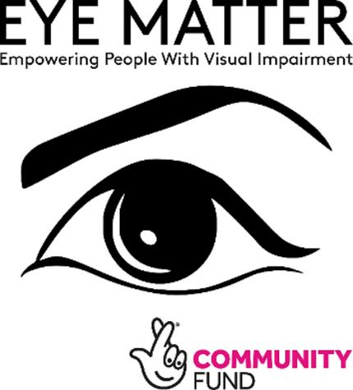
- Chair Yoga
- Poetry
- Book Club
- Audio Described Zumba Sessions
- Sailing Day & Picnic Break
- Tate Modern Audio Described Tour
- Neurobics, Aerobics for the Memory
- Sports Taster Days
- Audio Chair Yoga
- Social Gathering
- Drama Improv.
- Quiz Time
- Mental Health Wellbeing Group
- Discuss & Swap Survival Hacks
- Listen & Sing Along
For more information contact Suzie at Eye Matter
Call 07968 722664 or email info@eyematter.org.uk

A Clear Vision to Employment

A CLEAR VISION TO EMPLOYMENT COURSE
SAVE YOUR SPACE
CONTACT US FOR MORE INFO 020 8423 5141
EMPLOYMENTSERVICE@AFTB.ORG.UK

A CLEAR VISION TO EMPLOYMENT

MAB Board of Trustees
Chair – Mr Raj Mehta
Vice Chair – Mr Bharat Hindocha
Treasurer – Mr Nigel Liddell
Trustee – Ms Rachelle Goldberg
Trustee – Mr Qasim Khattak
Trustee – Mr Raphael Mennicken
Trustee – Mr Nick McCabe
Trustee – Ms Joshna Thakrar
Trustee – Ms Helen McGrath
Trustee – Ms Mena Shah
Trustee – Ms Sonia De Vito
Trustee – Mrs Alma Adade

Disability Sports Coach / Hillingdon Tech Sessions

Disability Sports Coach
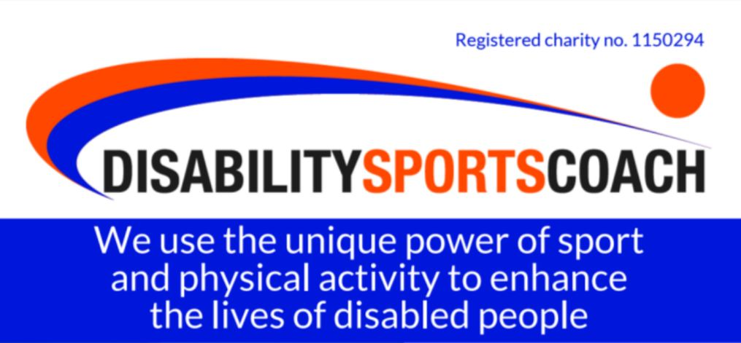
Registered charity no. 1150294
We use the unique power of sport and physical activity to enhance the lives of disabled people
PLUS join our free inclusive online activity sessions
Get in touch:
dsc@disabilitysportscoach.org.uk
www.disabilitysportscoach.org.uk
T: 020 7928 4267
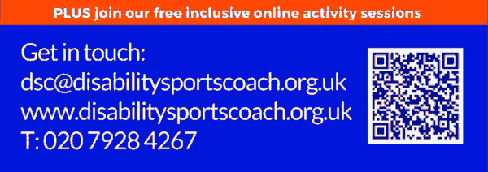

Group & 1-to-1 Tech Sessions

run on 19th August & 14th October 2026 at the Education Centre, Hillingdon Hospital.
For more info and to book, contact ECLO (Kerry) Tel 07864 954934. thh.eclo@nhs.net


Mind the Carer!

MindTheCarer@hfehmind.org.uk
0208 215 2243
Mind the Carer! is a service for Adult Carers that focuses on offering Mental Health support and community building to connect isolated Carers.

MAB VIP Social Clubs
The meetings are a chance for people to get together and make new friends. Through socialising at the clubs, people who are new to visual impairment are inspired by the people they meet. It is an opportunity to share challenges and victories, and to make social connections that go beyond the life of the monthly meeting. We currently run Monthly Clubs in all 9 Boroughs:

Barnet
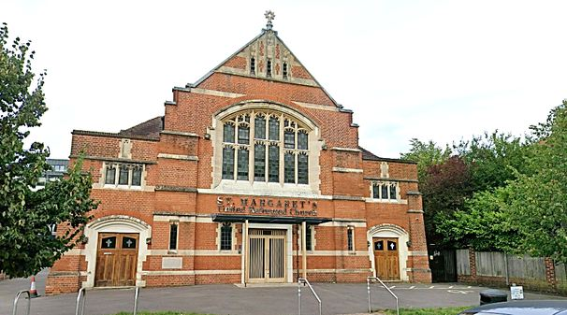
Our Barnet VIP Club runs from 11AM to 1PM, on the last Thursday of every month at St Margaret’s United Reform Church, Victoria Road, Finchley, N3 1BD

Brent
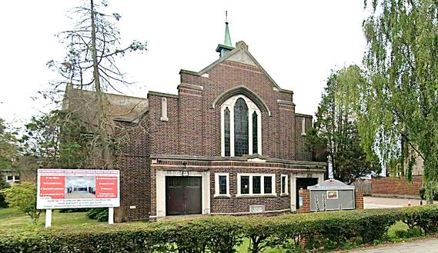
Our Brent VIP Club runs from 10.30AM to 12.30PM on the first Monday of each month at Sudbury Methodist Church, 809 Harrow Road, Wembley, London HA0 2LP

Ealing
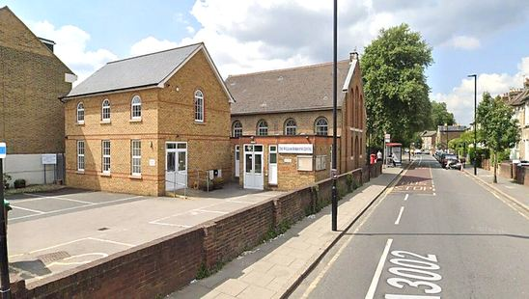
Our Ealing VIP Club Coffee Morning runs from 10.00AM to 1.00PM on the third Thursday of each month at the William Hobbayne Centre 1 St Dunstan’s Road W7 2EY

Ealing (Seasonal Trike Club)
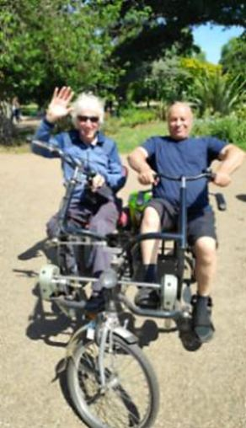
Our Seasonal Ealing Trike Club usually runs from 10.00AM to 1.00PM on one Thursday of each month (March to October only) in Walpole Park Mattock Lane W5 5EQ

Enfield
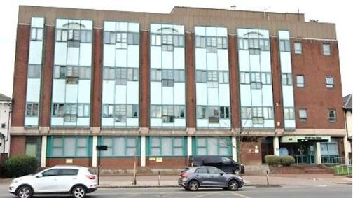
Our Enfield VIP Social Club runs from 11:00AM to 1:00PM on the first Tuesday of each month at Enfield Foyer, 279-281 Fore Street, Edmonton N9 0PD

Haringey
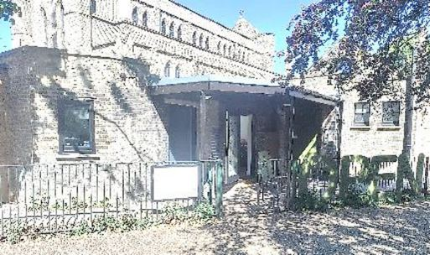
Our Haringey VIP Club runs from 11.00AM to 1.00PM on the second Wednesday of each month at The Hub, The Old Nursery, Town Hall Approach, Tottenham Green N15 4GZ

Harrow
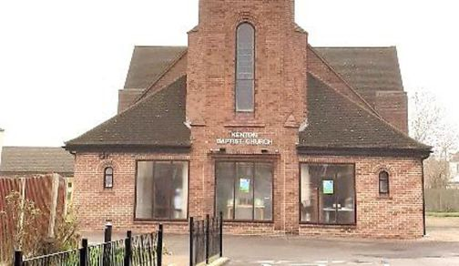
Our Harrow ‘Open Eyes’ VIP Club runs from 10:30AM to 12:30PM on the last Wednesday of each month at Kenton Baptist Church, Streatfield Road, Kenton, Middlesex HA3 9BS

Hillingdon
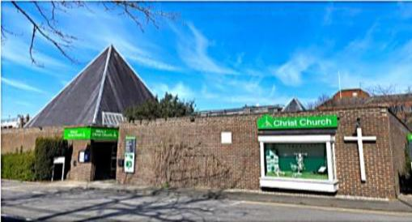
Our Hillingdon VIP Club runs from 10.30AM to 12.30PM on the last Thursday of each month at Christ Church, Redford Way, Belmont Road, Uxbridge UB8 1SZ

Hounslow
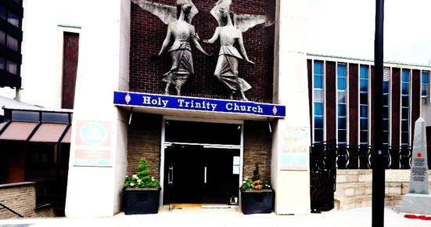
Our Hounslow VIP club usually runs from 11.00AM to 1.00PM on the Third Tuesday of the month at Holy Trinity Church, Café Area, 6 High Street, Hounslow TW3 1HG

Richmond
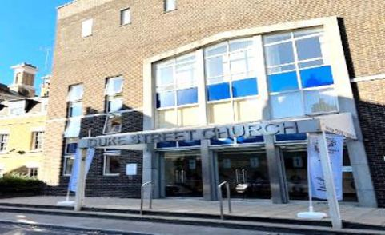
Our Richmond VIP Club runs from 10.30AM to 12.30PM on the third Monday of each month at Duke Street Church Meeting Room, Duke Street, Quadrant Road, Richmond TW9 1DH
For more details about our Social Clubs, please visit our website www.aftb.org.uk or call 020 8423 5141

Contact Numbers / Contributing to Outlook

MAB Borough Support Worker & Volunteer Coordinators
Table 1 MAB Borough Support Worker & Volunteer Coordinators
Borough | Name | Telephone No.
Barnet | Bina Padia | 07594 625215
Brent & Barnet | Rita Shah | 07510 127893
Ealing | Chanel Mahay | 07387 101631
Enfield | Gloria Powell | 07858 311410
Haringey | Caroline Adamson | 07754 875175
Harrow | Alison Bicknell | 07387 101632
Hillingdon | Joanne White | 07387 101630
Hounslow | Camilla Konieczny | 07511 826892
Richmond | Harvinder Sachdeva | 07503 671179

Borough Sensory Services Team Contact Numbers
Table 2 Borough Sensory Services Team Contact Numbers
Borough | Telephone No.
Barnet | 020 8359 5000
Brent | 020 8937 4300
Ealing | 020 8825 8757
Enfield | 020 8379 1001
Haringey | 020 8489 1400
Harrow | 020 8901 2680
Hillingdon | 01895 556 633
Hounslow | 020 8583 3100
Richmond | 020 8891 7971

Contributing to Outlook
We welcome contributions to the newsletter. Please send your Articles to Patricia Odina (patricia@aftb.org.uk).
This edition of Outlook is produced by:
Middlesex Association for the Blind
Suite D18 Freetrade House Lowther Rd Stanmore HA7 1EP
info@aftb.org.uk * 020 8423 5141 * www.aftb.org.uk
Find us on Facebook - @middlesexblind
Find us on Instagram - middlesexblind
Find us on LinkedIn - Middlesex Association for the Blind
Are you receiving this Newsletter in your preferred format?
Outlook is produced in the following formats:
- Large Print
- Braille
- On USB
- E-mail
- & Online In Print
- Audio Formats
at www.aftb.org.uk/outlook-magazine/

Thank You


A big Thank You to the Management & Community Champion Team at Morrisons Supermarket Honeypot Lane, Queensbury London NW9 6RN for allocating Free Car Parking Spaces to MAB Service Users and Staff.
Our sincere thanks to the following for allowing us to place MAB Collection Boxes on their premises:
- Joe’s Bake & Bite
5 Queensbury Station Parade HA8 5NP
- Bath Road Pharmacy
115-117 Bath Road Hounslow TW3 3BT
- Seven Oaks Court
Copsewood Way Northwood HA6 2TW

Established in 1999
Many thanks to the Magnifier Company for their Free Sample Magnifiers for our Service User demonstrations. For more info: www.magnifyingglasses.co.uk

To Angela Mistry and the Community Champion Team at the Sainsbury’s Superstore Kenton Nash Way, Kenton, Harrow HA3 0JA – A big Thank You for your continued support of our Monthly ‘Open Eyes’ VIP Social Club and Christmas Party.

Thank you to the team at Waitrose in South Harrow for their donations to our VIP Social Club in Harrow.

To the Management & Community Champion Team at Tesco Superstore, Ballards Lane, Finchley N3 1XP – A big Thank You for your continued support of our VIP Barnet Monthly Coffee Mornings.

Thank you to Barnet Copthall Leisure for hosting MAB Monthly Activity Days.

Jobs for the Disabled

To all our Trust, Foundation, Borough & Corporate Donors
~ Without you, we would not exist ~
Thank you for your continued support!

Our Valued Donors
At the Middlesex Association for the Blind, we are very grateful to all of our donors, without whom we simply would not exist. This year, our thanks go to the following funders:
London Boroughs of Barnet, Brent, Ealing, Enfield, Hounslow and Richmond; Access Foundation; Adobe Foundation; Alstom; Brent Health Matters; Childwick Trust; City Bridge; Clarion Housing Group; Edward Gostling Foundation; Gardners’ Trust; Garfield Weston Foundation; Hampton Fund; Harrow Giving; Heathrow Community Trust; Hedley Foundation; Hospital Saturday Fund; Investec Foundation; LNER & Bauer Media; London Community Foundation; Mercers’ Company Charity; Meridian Water; National Lottery Community Fund; Pathways Housing Association; The Primary Club; Richmond CVS; Richmond Foundation; Shanly Foundation; Thames Reach; Thomas Wall Trust; Ulverscroft Foundation; Worshipful Company of Builders Merchants; Worshipful Company of Coopers; Worshipful Company of Drapers; Worshipful Company of Environmental Cleaners; Worshipful Company of Gold and Silver Wyre Drawers; Worshipful Company of Innholders; Worshipful Company of Spectacle Makers; Worshipful Company of Tobacco Pipe Makers and Tobacco Blenders.
We are proud and grateful to be able to display their logos below.
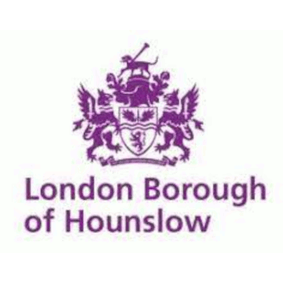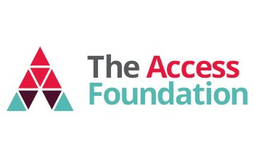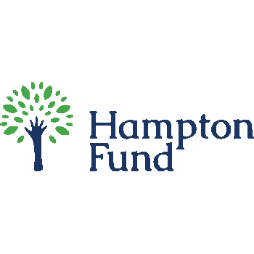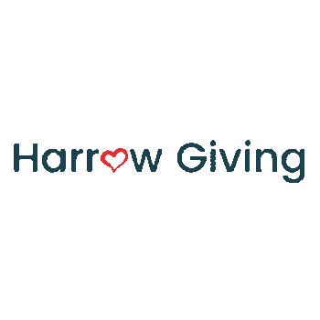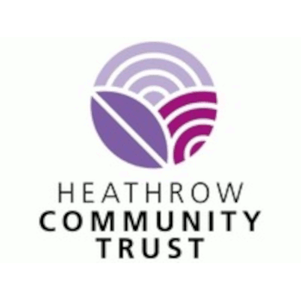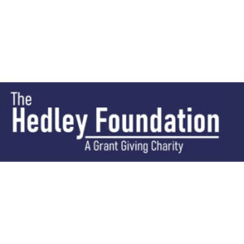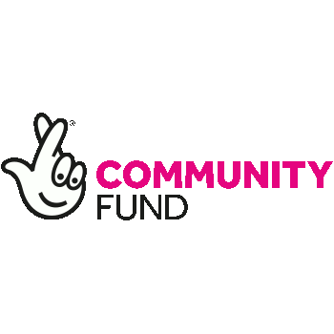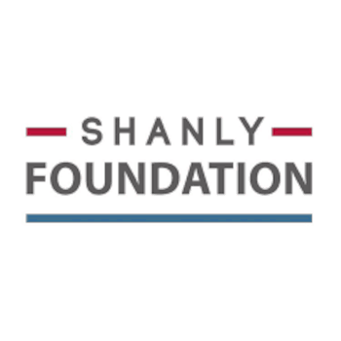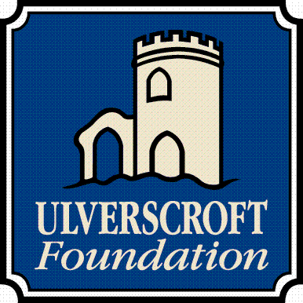
Donor list and logos as published on our website (aftb.org.uk/our-donors), July 2026.
Middlesex Association for the Blind, registered charity no. 207007. Accessible edition of the OUTLOOK magazine, Spring / Summer Edition 2026.

